Faculty of Engineering, Science & Technology

IQRA UNIVERSITY



Programming Fundamentals

Project Report

[Summer-2023]

Name of 1st Member: Muhammad Zain

Registration no of 1st Member: **16121**

Name of 2nd Member: Okasha Nadeem Jafree

Registration no of 2nd Member: **16239**

Semester of both member’s: **Summer Semester**

Batch: 2023

PROJECT NAME: **FAST FOOD MANAGEMENT SYSTEM**

*Instructor Name:* Ghazala Shafi Sheikh

Acknowledgment

*We would like to sincerely thank our lecturer at the IQRA University Airport Campus,* ***Miss Ghazala Shafi Sheikh,*** *for her important advice and assistance throughout the creation of this project. Our understanding of project management and programming ideas has been greatly influenced by her knowledge and support.*

*Thank you*

*Miss Ghazala Shafi Sheikh*

***Chapter 1 Index Pages***

Objectives 4

***Chapter 2***

Introduction 6

***Chapter 3***

Description 7

***Chapter 4***

Coding 8

***Chapter 5***

Screen Shots 15

***Chapter 6***

Conclusion 21

***1.Objectives:***

***Functional Fast Food Management System:***

*Create a functional program that allows users to browse a menu, select food items, specify quantities, and place orders.*

***Accurate Billing Calculation:***

*Implement a billing system that accurately calculates the total cost of the selected food items, considering their prices and quantities.*

***Order Management:***

*Develop the ability to manage orders, including adding, updating, and removing items from an order before finalizing it.*

***Employee Management:***

*Create features for adding, updating, and removing employees.*

***Sales Tracking:***

*Implement a daily sales tracking mechanism that records the total sales made each day, providing insights into the business's performance.*

***Menu Display:***

*Design a user-friendly menu display that lists available food items along with their corresponding prices and descriptions.*

***User Interaction:***

*Enable smooth interaction with the user through well-defined prompts and clear instructions, ensuring a seamless ordering experience.*

***Input Validation:***

*Incorporate input validation mechanisms to prevent errors and ensure that users enter valid data, such as correct item numbers and quantities.*

***2.Introduction:***

Introducing our innovative Fast Food Management System, a powerful and user-friendly solution designed to streamline the food ordering experience while enhancing the management of your culinary business. Built from the ground up using the C programming language, our system offers a seamless platform that allows customers to effortlessly place food orders, receive accurate bills, and enjoy a variety of customizable menu items. But that's not all – our program goes beyond the customer experience. With the capability to manage employees, track daily sales, and monitor business performance.

***3.Description:***

Incorporating a versatile and modular design, our Fast-Food Management System provides a seamless experience for both customers and business owners. It's not just a program; it's a solution that simplifies food ordering, enhances employee management, and provides valuable insights into your business's success.

* *Program will ask you to select between Menu, Employee Details, Sales Leasure or Exit.*
* *If you select MENU, Program will show you a menu of different available fast foods that we have. Now you have to select one of foods like press 1 to select zinger burger. Now you have to select quantity of food. After that, It will ask you to select 1 for shop more or select 2 to print bill. After that when you press 2, program will show you total amount.*
* *If you select Employee Details by pressing 2, You can add, remove or show employees.*
* *If you select Sales Leasure by pressing 3, Program will show you today sales.*
* *I Hope You Like It !!*

***4.Coding:***

#include <stdio.h>

#include <string.h>

int main(){

char empname[5][50];

char employee[20];

int select,item,total=0,repeat,menuloop;

int zingloop,beefloop,clubloop,broastloop,cdloop;

int zingcount=0,beefcount=0,clubcount=0,broastcount=0,drinkcount=0;

int zingtotal=0,beeftotal=0,clubtotal=0,broasttotal=0,cdtotal=0;

int empselect,empnum,rej;

int salesleasure=0;

printf("::::::::::::::::::::FAST FOOD MANAGEMENT SYSTEM:::::::::::::::::::::::::::\n\n");

while(1){

printf("You Can Select Following Options:\n\n");

printf("1.MENU\n2.Employee Details\n3.Sales Leasure\n4.Exit\n\n");

printf("Select: ");

scanf("%d",&select);

repeat=1;

if(select==1){

while(repeat){

printf("===============MENU===================\n\n");

printf("1.Zinger Burgur Rs 350\n2.Beef Burgur Rs 280\n3.Club SAndwich Rs 330\n4.Broast Rs 400\n5.Cold Drink Rs 100\n");

printf("\nSelect: ");

scanf("%d",&item);

if(item==1){

printf("\nHow many Zingers do you want :");

scanf("%d",&zingloop);

for(int i=0;i<zingloop;i++){

zingcount=zingcount+1;

zingtotal=zingtotal+350;

total=total+350;

}

}

else if(item==2){

printf("\nHow many Beef Burgurs do you want :");

scanf("%d",&beefloop);

for(int j=0;j<beefloop;j++){

beefcount=beefcount+1;

beeftotal=beeftotal+280;

total=total+280;

}

}

else if(item==3){

printf("\nHow many Club Sandwitches do you want :");

scanf("%d",&clubloop);

for(int k=0;k<clubloop;k++){

clubcount=clubcount+1;

clubtotal=clubtotal+330;

total=total+330;

}

}

else if(item==4){

printf("\nHow many Broast do you want :");

scanf("%d",&broastloop);

for(int l=0;l<broastloop;l++){

broastcount=broastcount+1;

broasttotal=broasttotal+400;

total=total+400;

}

}

else if(item==5){

printf("\nHow many Cold Drinks do you want :");

scanf("%d",&cdloop);

for(int m=0;m<cdloop;m++){

drinkcount=drinkcount+1;

cdtotal=cdtotal+100;

total=total+100;

}

}

else{

printf("Please Enter Valid Command \n");

}

printf("Do you want to shop more?\n");

printf("Press 1 to shop more\nPress 2 to print bill\nEnter Here :");

scanf("%d",&menuloop);

if(menuloop==2){

printf("-----------------BILL--------------------\n");

printf("%d Zinger Burgur 350 X %d = %d\n",zingcount,zingcount,zingtotal);

printf("%d Beef Burgur 280 X %d = %d\n",beefcount,beefcount,beeftotal);

printf("%d Club Sandwitch 330 X %d = %d\n",clubcount,clubcount,clubtotal);

printf("%d Broast 400 X %d = %d\n",broastcount,broastcount,broasttotal);

printf("%d Cold Drink 100 X %d = %d\n",drinkcount,drinkcount,cdtotal);

printf(" ----\n");

printf(" Total %d\n",total);

salesleasure+=total;

total=0;

zingcount=0;

zingtotal=0;

beefcount=0,beeftotal=0;

clubcount=0,clubtotal=0;

broastcount=0,broasttotal=0;

drinkcount=0,cdtotal=0;

repeat=repeat-1;

}

}

}

else if(select==2){

repeat=1;

while(repeat){

printf("\n1.Add Employee\n2.Remove Employee\n3.Show Employees\n4.Exit\n");

scanf("%d",&empselect);

if(empselect==1){

printf("How many Employees Do you want to Add:");

scanf("%d",&empnum);

for(int a=0;a<empnum;a++){

printf("Enter Employee Name :");

scanf("%s",&empname[a]);

}

}

else if(empselect==2){

printf("Enter employee (1-5): ");

scanf("%d", &rej);

if (rej >= 1 && rej <= 5) {

printf("Removing Employee: %s\n", empname[rej - 1]);

strcpy(empname[rej - 1], "empty");

// Print updated list of employees

printf("Updated Employee List:\n");

for (int i = 0; i < 5; i++) {

if (strcmp(empname[i], "empty") != 0) {

printf("%s\n", empname[i]);

}

}

}

}

else if(empselect==3){

printf("\n==========================Employee Details==================\n");

for(int a=0;a<empnum;a++){

printf("%s\n",&empname[a]);

}

}

else if(empselect==4){

repeat=repeat-1;

}

else{

printf("Invalid employee selection.\n");

}

}

}

else if(select == 3){

printf("\n\n:::::::::::::::SALES LEASURE:::::::::::::::::::::\n");

printf("\nToday\'s Total Sales: %d\n\n ", salesleasure);

printf("-----------------------------------------------------\n\n");

}

else if(select==4){

printf("\n\n::::::::::::::EXIT:::::::::::::\n\n");

break;

}

else{

printf("---------------------------------");

printf("\nPlease Enter Valid Command!\n");

printf("---------------------------------\n");

}

}

return 0;

}

***5.Screen Shots:***

First Program will wait for you to select between Menu, Employee Details, Sales Leasure or exit.

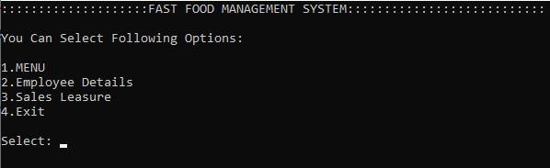

Let’s Select Menu by pressing 1.

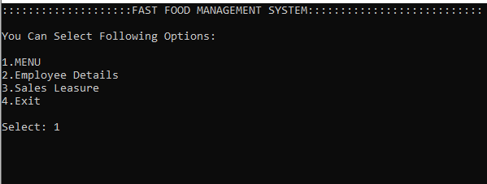

After pressing Enter, Program will show us the Menu.

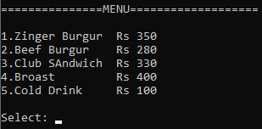

Now you have to select fast food between one of them, Let’s select Zinger Burger by pressing 1.

After pressing Enter, Program will wait for you to enter quantity.

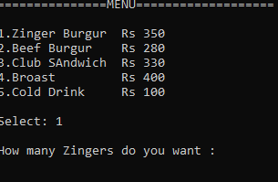

Now we can enter quantity, Let’s Enter 1 quantity.



After that, Program will wait for you to shop more by pressing 1 or print bill by pressing 2.

Let’s print bill.

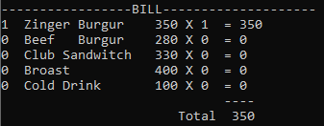

Now, Let’s select Employee Details by pressing 2.

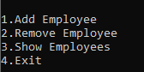

Here are the options that you can select by pressing numbers.

Let’s add employees by pressing 1.



Now the program will wait for you to enter quantity of how many employees do you want to add.

Let’s add 1 employee by pressing 1 and enter.



Now the program will wait for you to enter employee name.

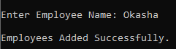

After that It will show you that employee added successfully.

Now let’s see our available employees by pressing 3.



Boom! Here we have Okasha that we just added him as a employee and now we can see him in our employee details.

Now, Let’s remove Okasha by pressing 2 to select Remove Employee.



Now you have to enter employee number, Here Okasha is on number 1 so let’s select 1 and press enter.

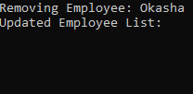

Here we have removed Okasha and then the program showed us updated employee list. It’s Empty because we entered only Okasha in our employee list no one else!

Let’s check Today Sales Leasure by pressing 3.

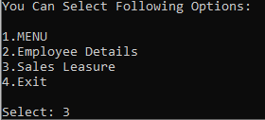

Here is the today sales leasure because we selected only zinger burger from menu.

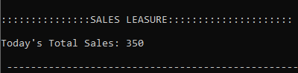

Now we can exit by pressing 4.

I HOPE YOU LIKE IT!!!!

***6.Conclusion:***

*In conclusion, our Fast-Food Management System, meticulously crafted using the power of C programming, brings together the best of both worlds: customer convenience and comprehensive business control. Seamlessly handling food orders, generating accurate billing, and catering to customization needs, the system ensures a smooth and delightful ordering experience for our valued customers.*